Hello,

This is Jasmine Hur (n10622012) who takes the CAB432 class.

Thank you for your tutorial class, it’s useful and helpful indeed!

I would like to confirm my first assignment contents whether it is ok or not.

**First, combining music festival in USA with Leaflet.**

**API 1**: <https://seatgeek.com/>

This API search the geeks near by your place, but it looks working well within USA. When I search in AU it doesn't look working.

It required client ID to use API, I’ve got client ID already. And it results can be shown as a object like underneath.

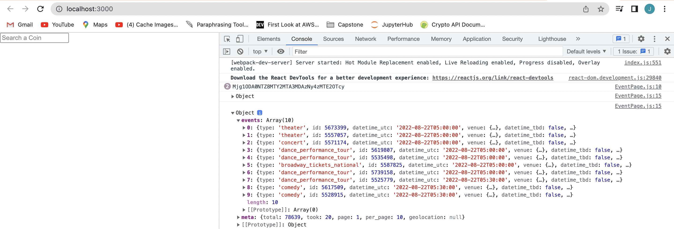

**API 2**: <https://leafletjs.com/>

The leaflet API search the point of place with latitude and longitude.



**API**

So, combining both APIs, when you go to USA, you can check the gigs with the dates (using calendar npm) and enjoy the concerts. Also, the page will look like the screenshot.

Date

Date

**Second, combining cryptocurrency & coinatmradar**

This subject is that I really want to try but Coin ATM Radar isn’t answering my email and there is no much resource about cryptocurrency ATM map.

So, If I can use coinatmradar then I will go with this subject.

**API 1**: <https://www.coingecko.com/en/api>

It doesn’t need client ID or Key. Now it looks like the screenshot.

**API 2**: <https://coinatmradar.com/>

I cannot use this API, I’ve been waiting the answer from CoinATMRadar. If I can use that it will be look like the screenshot.

So, when you are travelling somewhere, and If you don’t have enough money you can check price of coin you have, and you can find the store that can accept coin as a real money.

Those two subjects are that I’m planning to create. I think the project will be carried out with a high probability on the first topic. What does think of my project? Thank you.